**Report No.3: System Requirements Specifications (SRS)**

**3.1. User Requirement Specification**

1. **1 Guest Requirement**

*Guest is a person who doesn’t have access to the system. Guest only try some demo features. To use all functions, guest must login. These are some functions guest can use:*

* Login
* Register

**3.1.2 Authorized User Requirement**

*Authorized User is an authorized user who has permission to login into the system. Authorize User can use below functions:*

* Log out
* View profile
* Update profile
* Deactivate profile

**3.1.3 Homeowner Requirement**

*Homeowner is an authorized user who has permission to login into the system. With Homeowner role, user can use all functions of Authorized User and below functions:*

* Post scrap for sale
* Chat with collector
* Call collector
* Review collector
* Update post information
* View post history
* Delete post
* Accomplish post
* View scrap price negotiation from Collector
* Accept scrap price negotiation
* Reject scrap price negotiation
* View scrap price negotiation from Collector
* Accept scrap price negotiation
* Reject scrap price negotiation
* Review Collector

**3.1.4 Collector Requirement**

*Collector is an authorized user who has permission to login into the system. With Collector role, user can use all functions of Authorized User and below functions:*

* Search near by scraps
* View scrap detail
* Negotiate scrap price
* Book scrap
* Call Homeowner
* Chat with Homeowner
* View pick-up schedule
* View direction
* View scrap price negotiation response
* View scrap booking response
* View booking list
* Cancel booking
* Accomplish booking
* View review

**3.1.5 Admin Requirement**

*Admin is an authorized user who has permission to login into the system. With Admin role, user can use all functions of Authorized User and below functions:*

* Activate account
* Deactivate account
* Activate category
* Deactivate category
* Add new category
* Activate post
* Deactivate post

**3.2. System Requirement Specification (Specific Requirements)**

3.2.1. External Interface Requirements

3.2.1.1. User Interfaces

* GUI should be simple, clear, intuitive, and reminiscent.
* The interface design is an iterate process includes: designing, sketching, prototyping and user assessment.
* Website and mobile application must be responsive, suitable with all devices resolution such as: laptop, tablet or smartphone.
* Every feature should be arranged and displayed briefly.
* The User Interface uses language is Vietnamese.

3.2.1.2. Hardware Interfaces

* Laptop or Personal Computer
* Smartphone or Tablet

3.2.1.3. System Interfaces

* The website works with Firefox (v57 or above), Chrome (v51 or above), Safari (v5 or above) or any web browser which supports HTML5 & CSS3.
* The mobile app work best on android version 6.0.1+.

3.2.1.4. Communications Protocol

* Use HTTP protocol 1.1 for communication between:
  + Web application and web service
  + Mobile application and service

3.2.2. System Overview Use Case

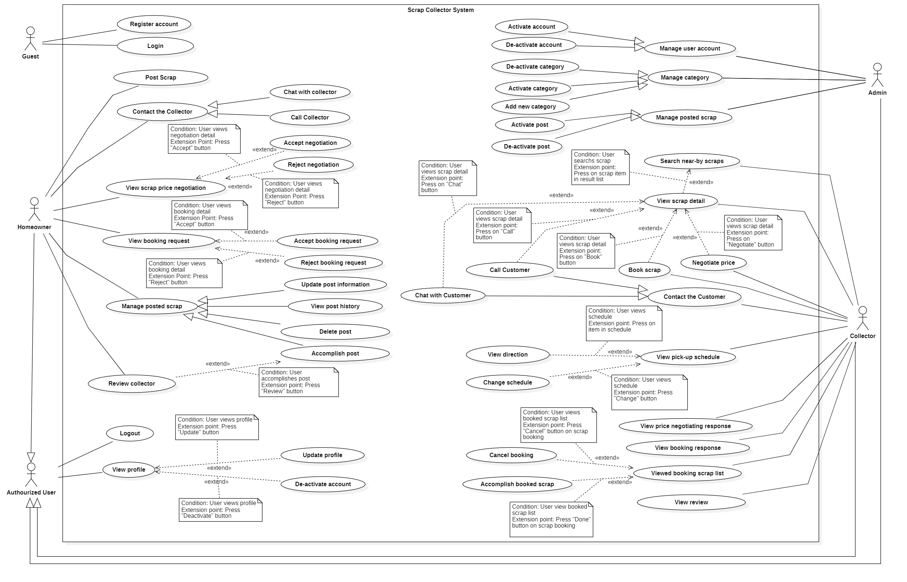

Figure: Use Case Diagram

3.2.3 List of use case

3.2.3.1

**3.3 Software System Attribute**

3.3.1 Usability

* The system is easy to use that needs less than 2 hour of training to use the system.
* User does not need to have knowledge in any field of computer or programming still understand meaning of user interface

3.3.2 Reliability

* Every information stored in the database is permanent
* Exception rate is at minimum 1% over all working time

3.3.3 Availability

* The system must be available 24/7, except for some system maintenances

3.3.4 Security

* Input data must be validated before being saved to the database
* Only Admin has fully access to the wen application
* Password is encrypted before being saved to the database
* For each request to get API from user, server checks if the user token is correct
* The code is based on popular design patterns in order to easy to maintain and upgrade.

3.3.5 Maintainability

* The system is divided into separated sub-systems or modules for easy maintain

3.3.6 Portability

* The website is running on Windows 7 or above.
* Easy installation from APK for Android version.
* The mobile application is running on Android 6.0.1 or above.

3.3.7 Performance

* All requests are handling in maximum duration of 10 seconds
* System has successfully test with basic standard

**3.4. Conceptual Diagram**

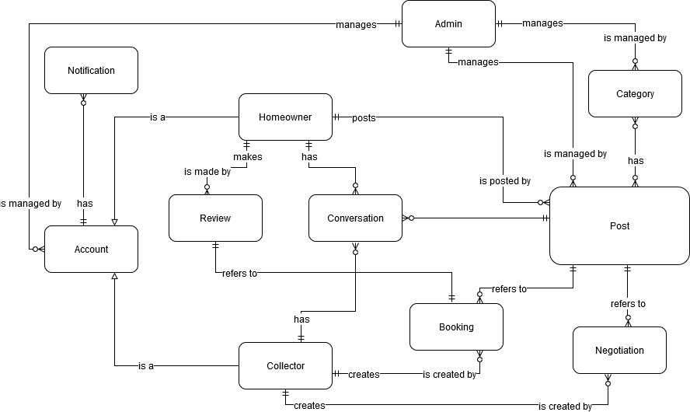

Figure: Conceptual Diagram

**Data Dictionary**

|  |  |
| --- | --- |
| **Entity Data dictionary: describe all content of all entities** | |
| **Entity Name** | **Description** |
| **Account** | Abstract entity describes a user in system |
| **Homeowner** | Contain the homeowner information |
| **Collector** | Contain the collector information |
| **Admin** | Contain the admin information |
| **Notification** | Contain the notification information |
| **Post** | Contain the post information |
| **Category** | Contain the category information |
| **Booking** | Contain the booking information |
| **Negotiation** | Contain the negotiation information |
| **Review** | Contain the review information |
| **Conversation** | Contain the conversation information |

Table: Conceptual Diagram Data Dictionary